**Assignment – 3.1**

PENNA BHARGAVI

2303a52391

Batch : 44

**1. Sentiment Classification for Customer Reviews**

**Scenario:**

An e-commerce platform wants to analyze customer reviews and classifyWeek2them into Positive, Negative, or Neutral sentiments using promptengineering.

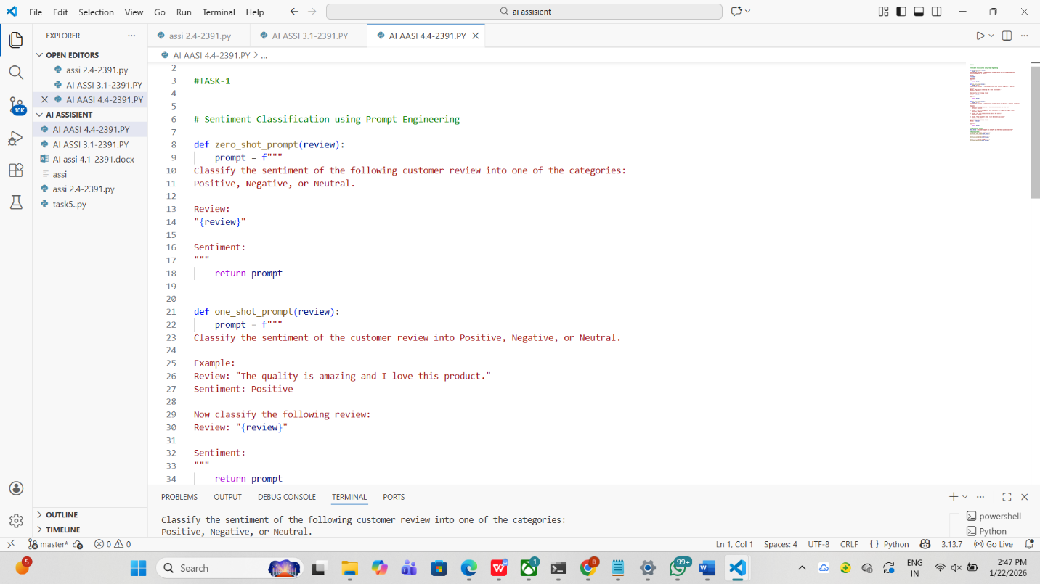

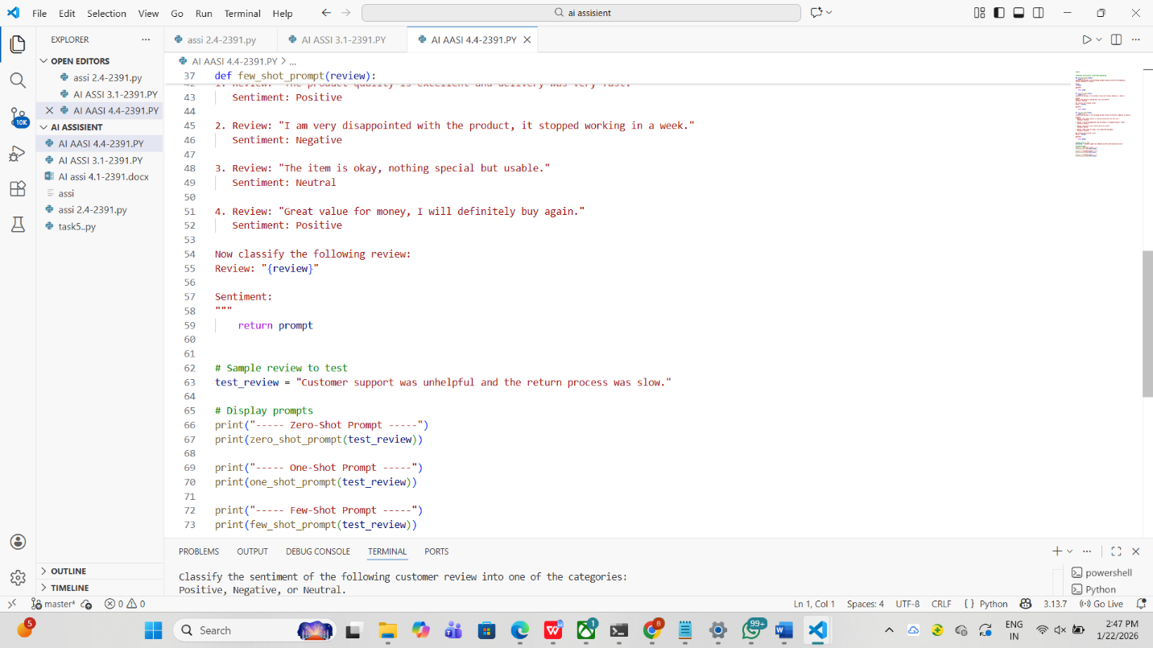

OUTPUT:

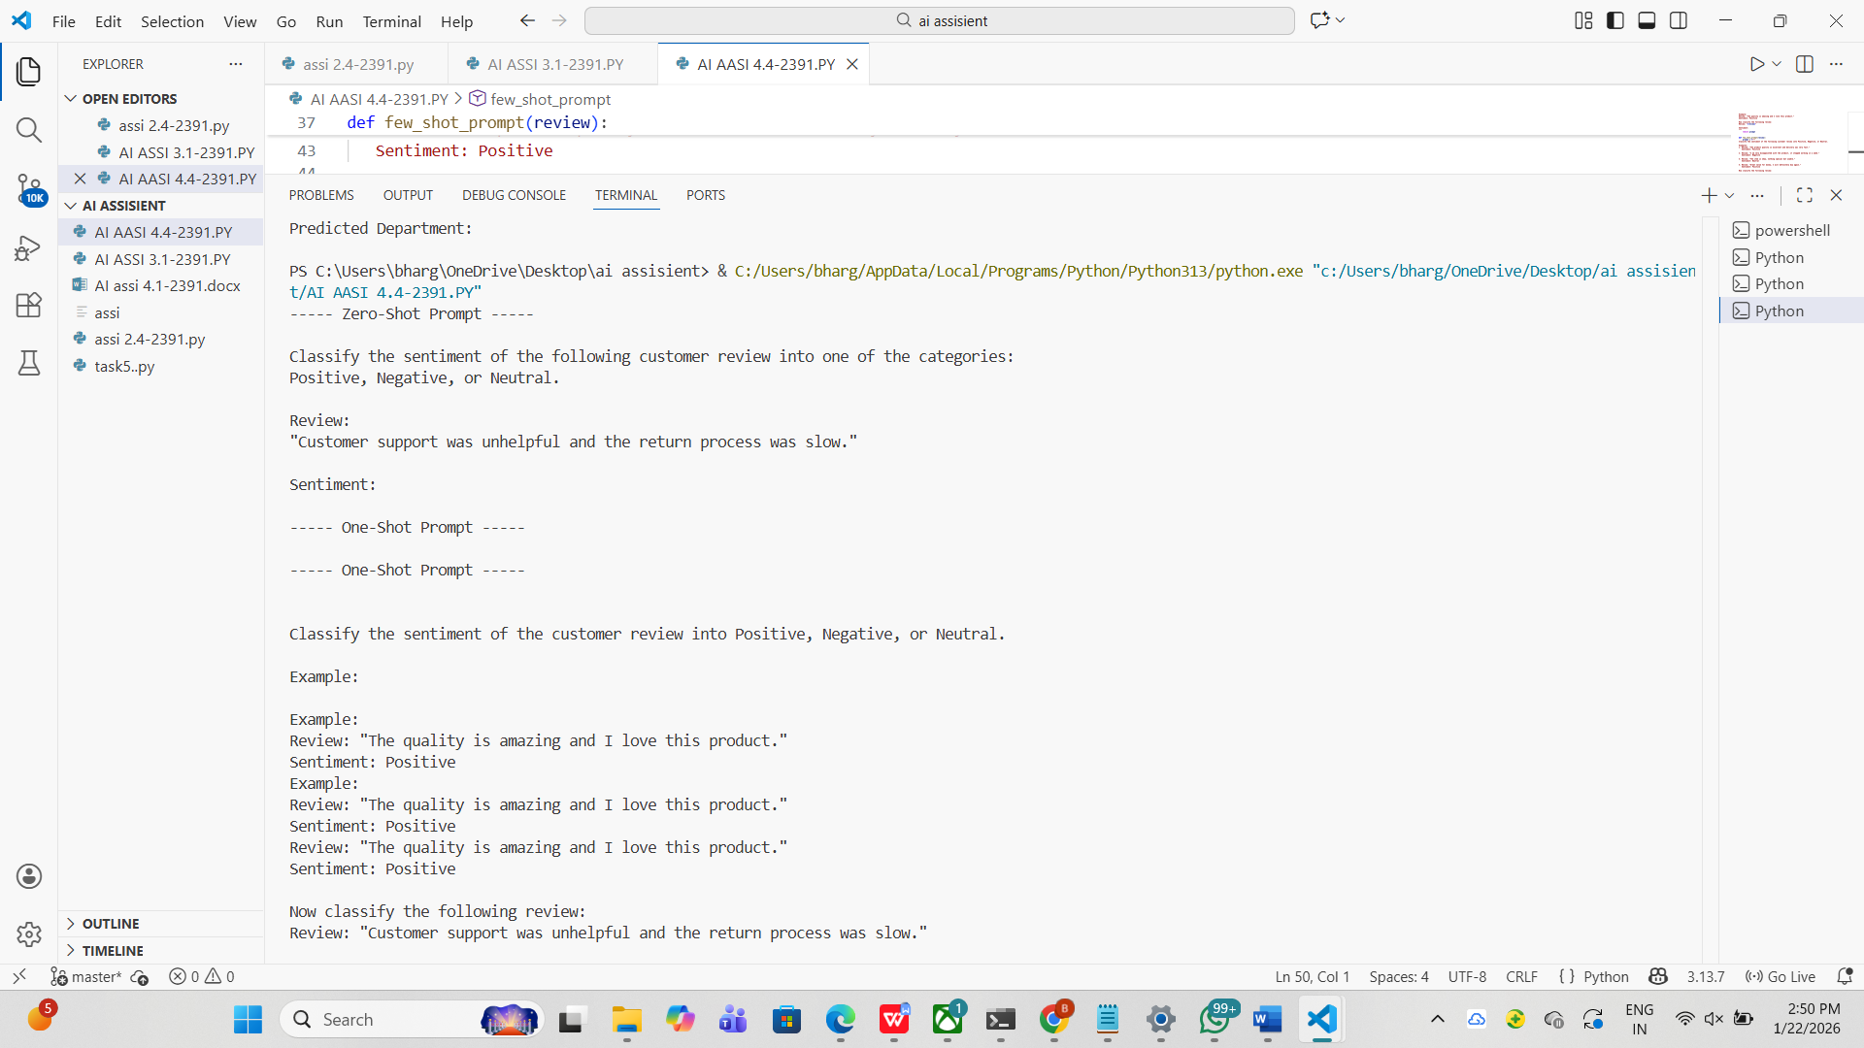

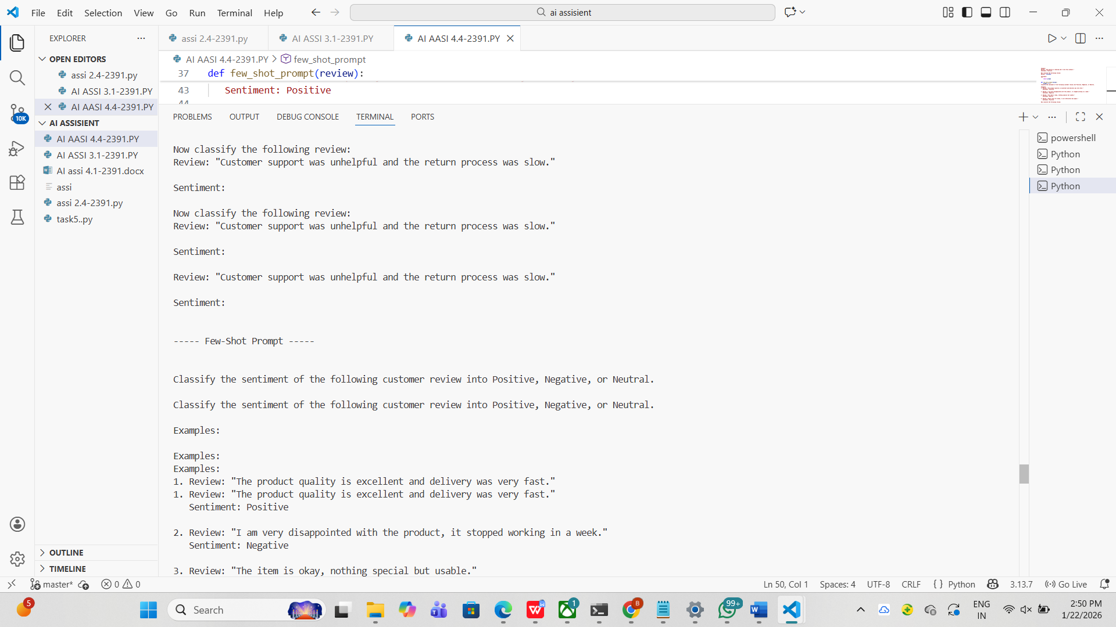

**2. Email Priority Classification**

**Scenario:**A company wants to automatically prioritize incoming emails into HighPriority, Medium Priority, or Low Priority.

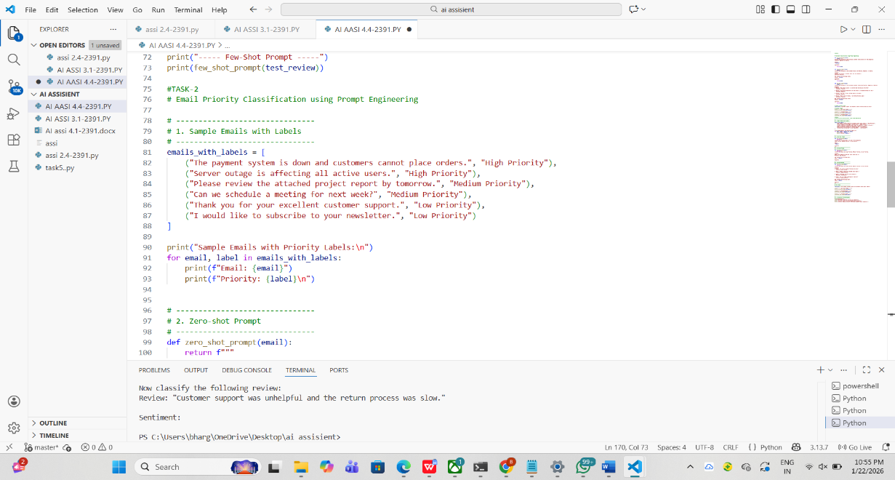

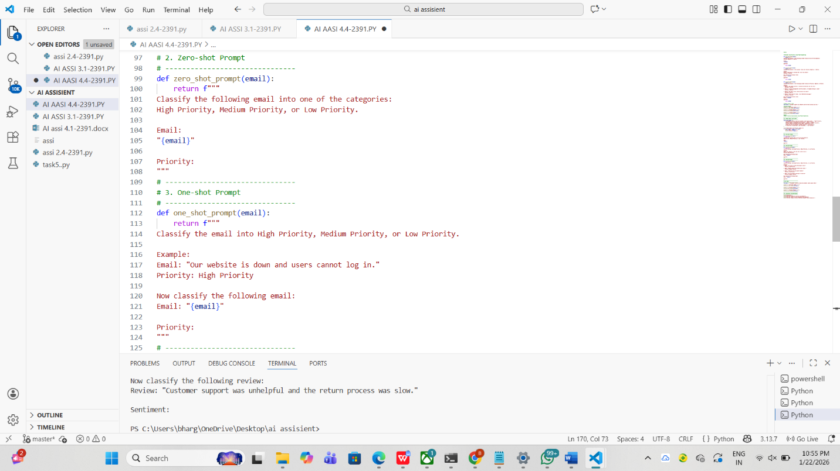

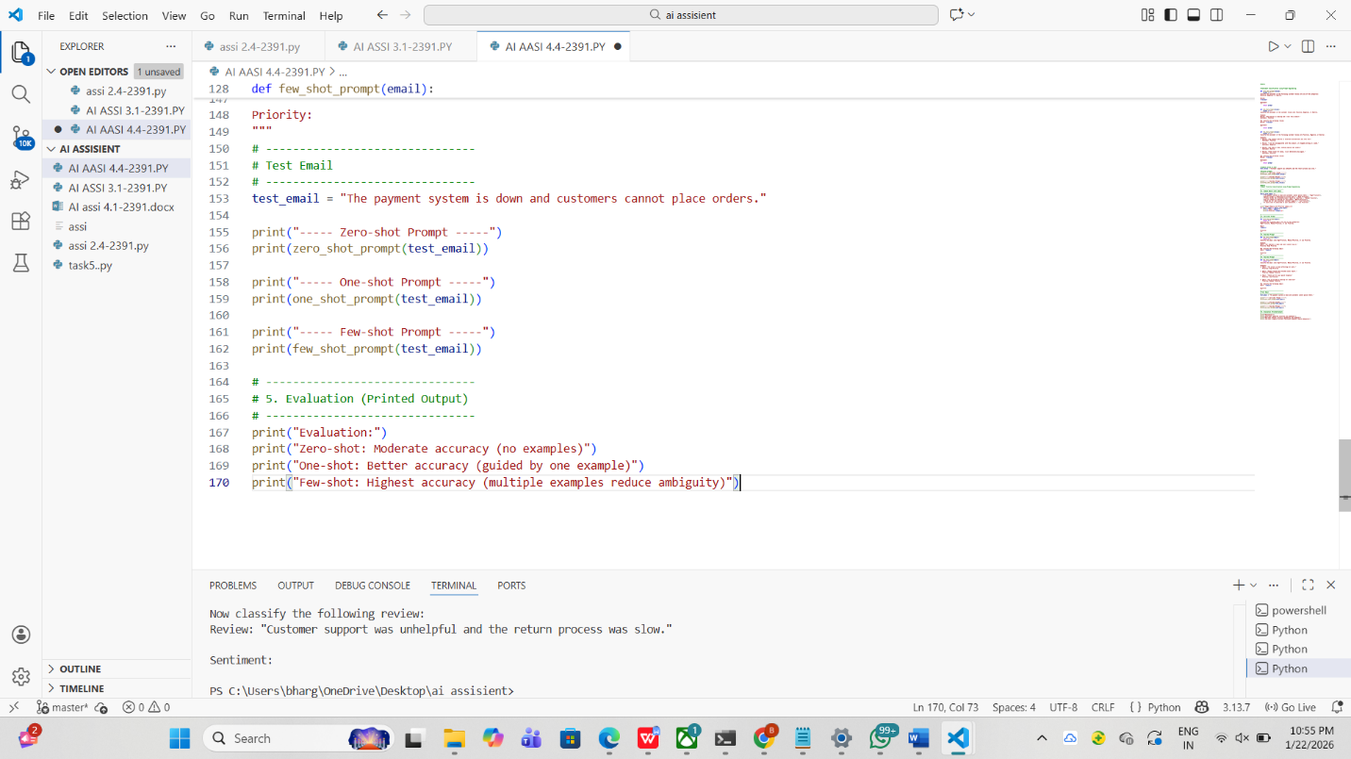

OUTPUT:

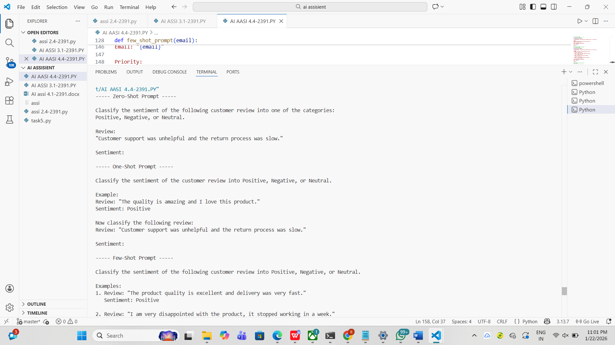

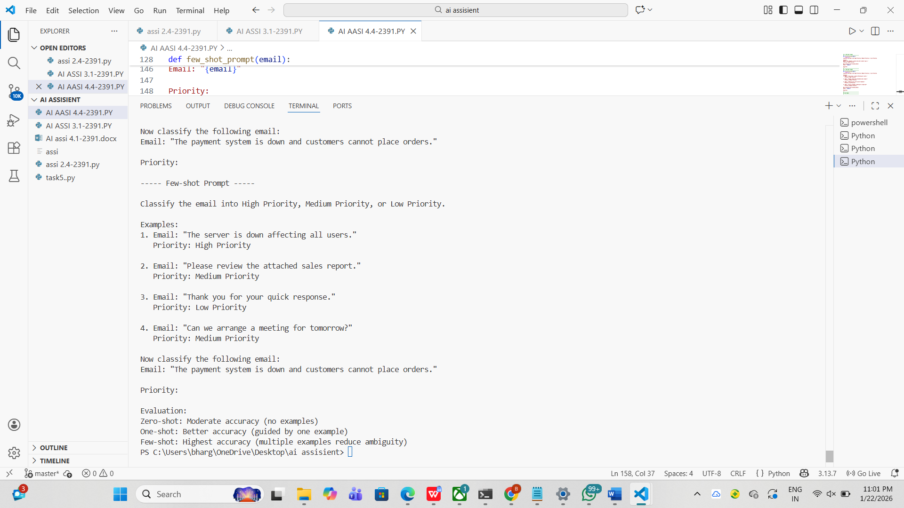

**3. Student Query Routing System**

**Scenario:A university chatbot must route student queries to Admissions, Exams,**

**Academics, or Placements**

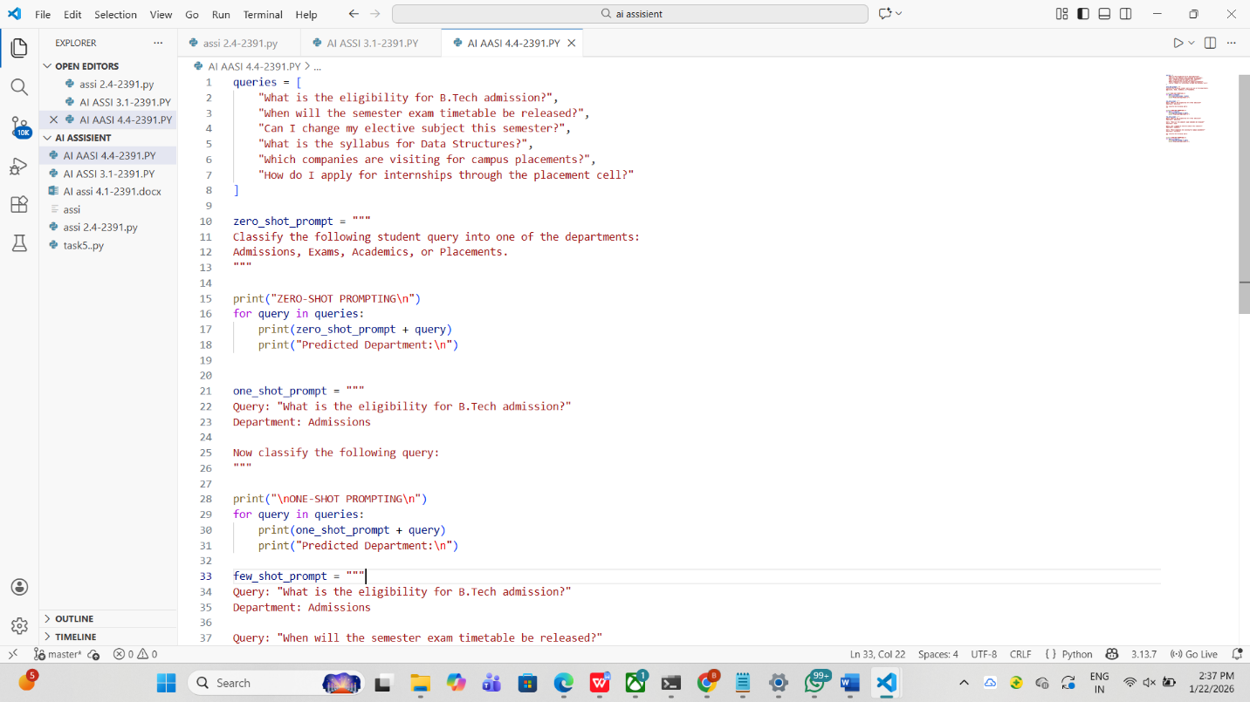

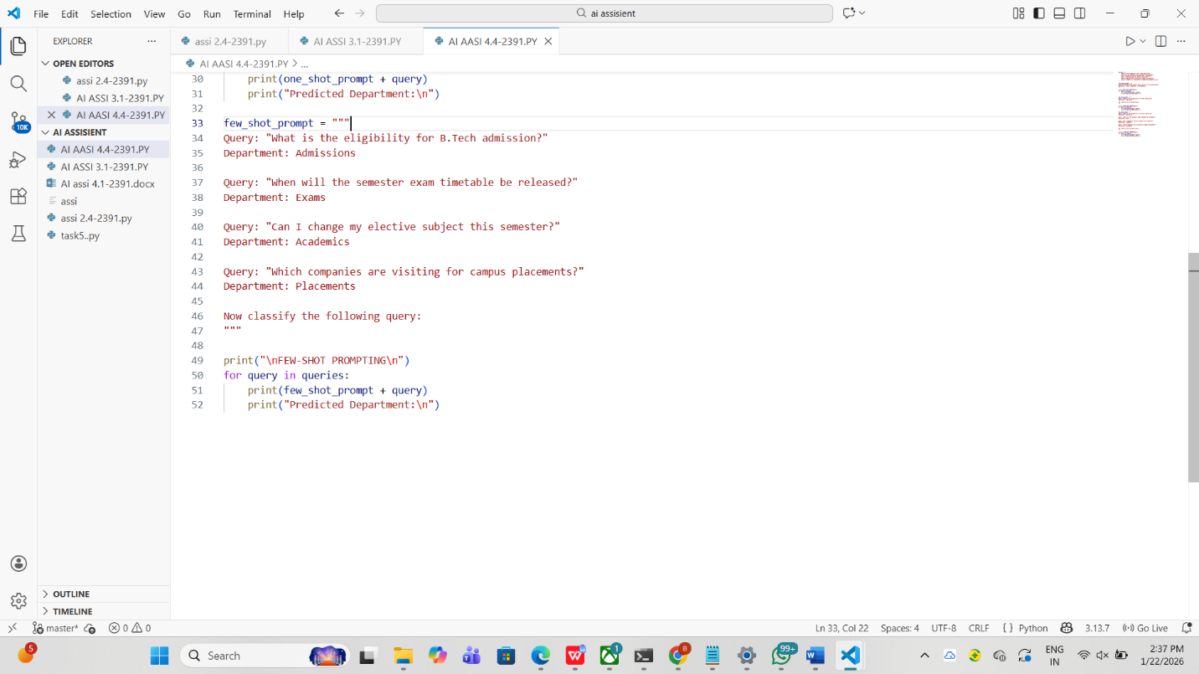

OUTPUT:

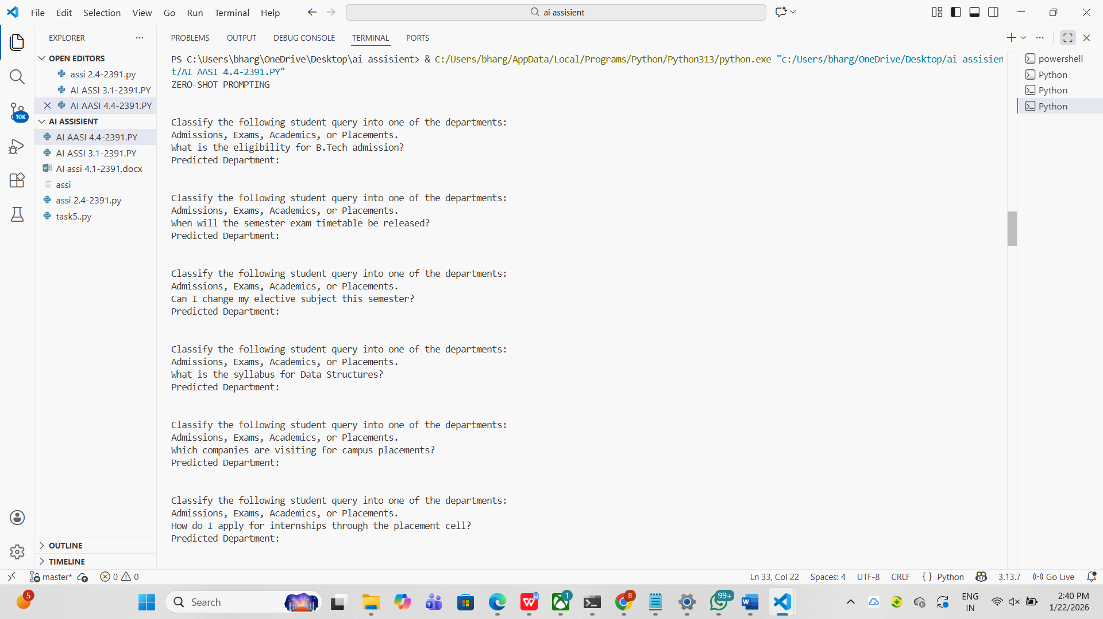

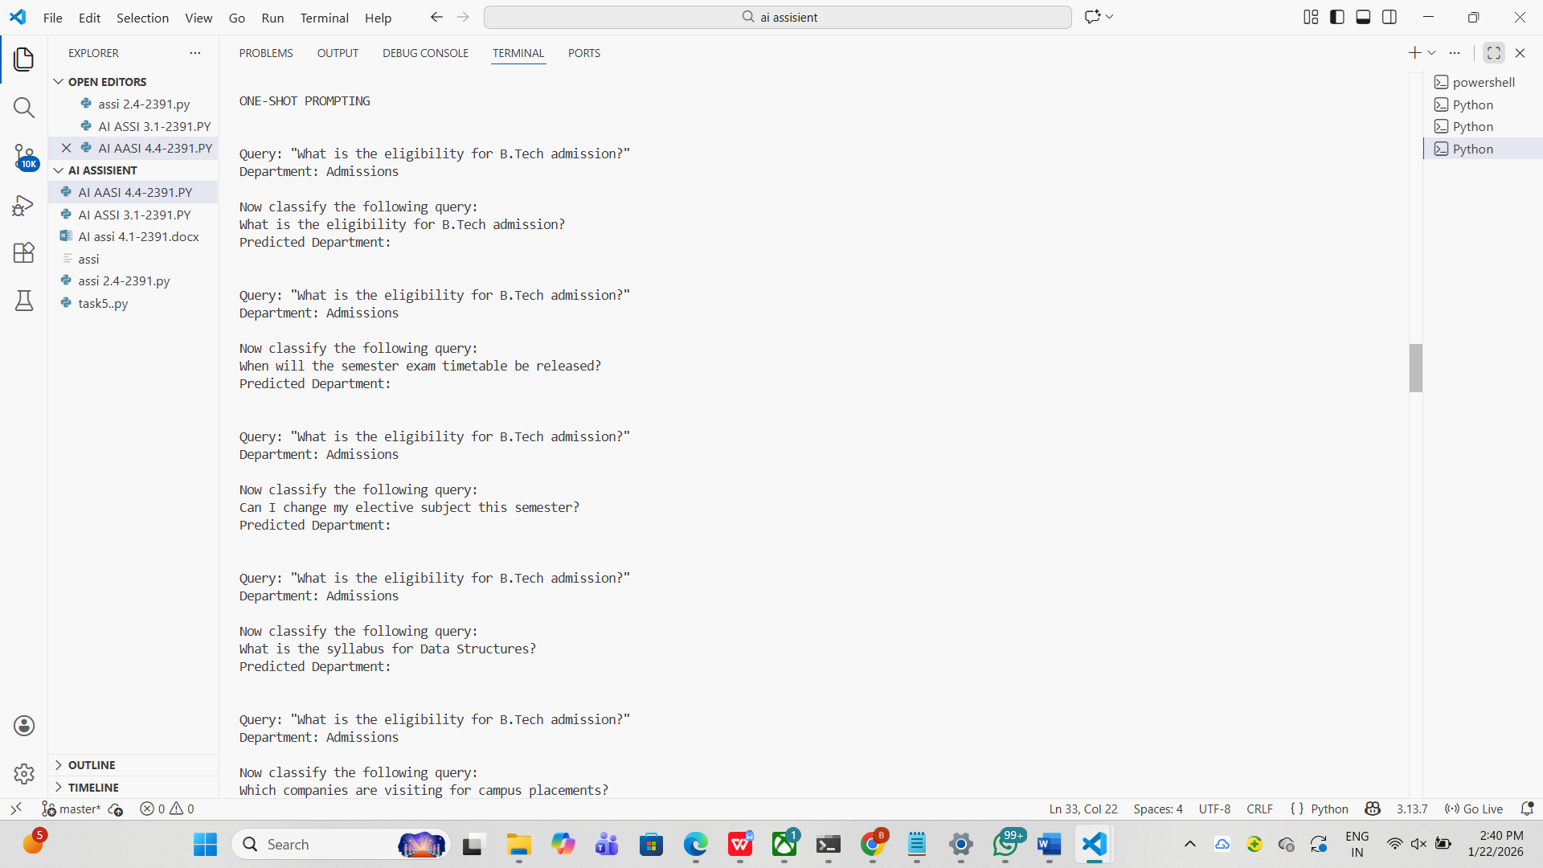

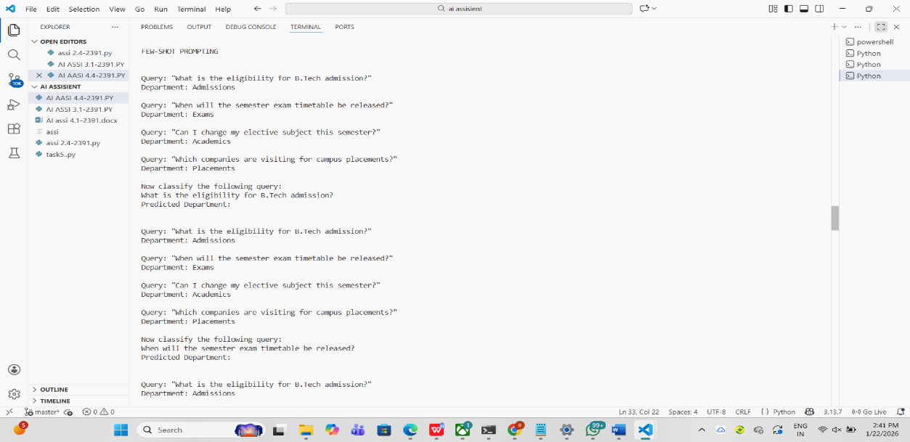

**4. Chatbot Question Type Detection**

**Scenario:A chatbot must identify whether a user query is Informational,**

**Transactional, Complaint, or Feedback**

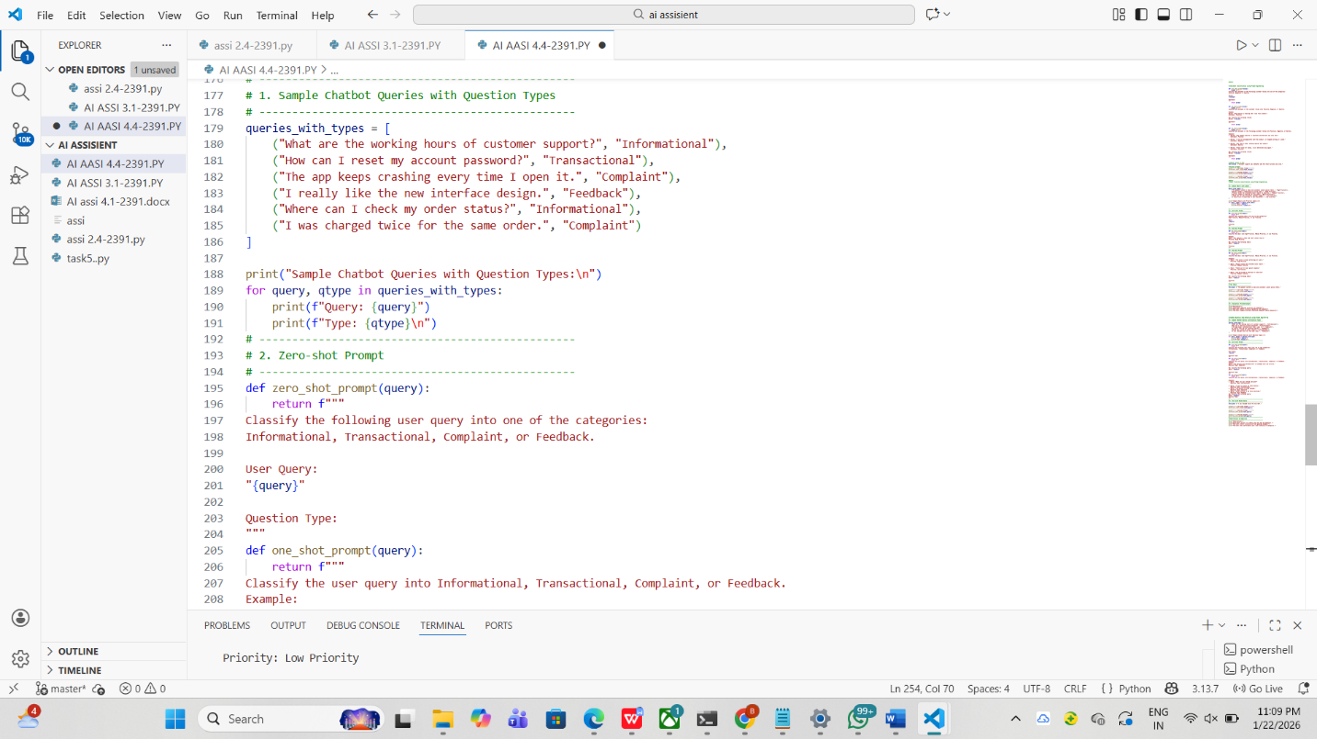

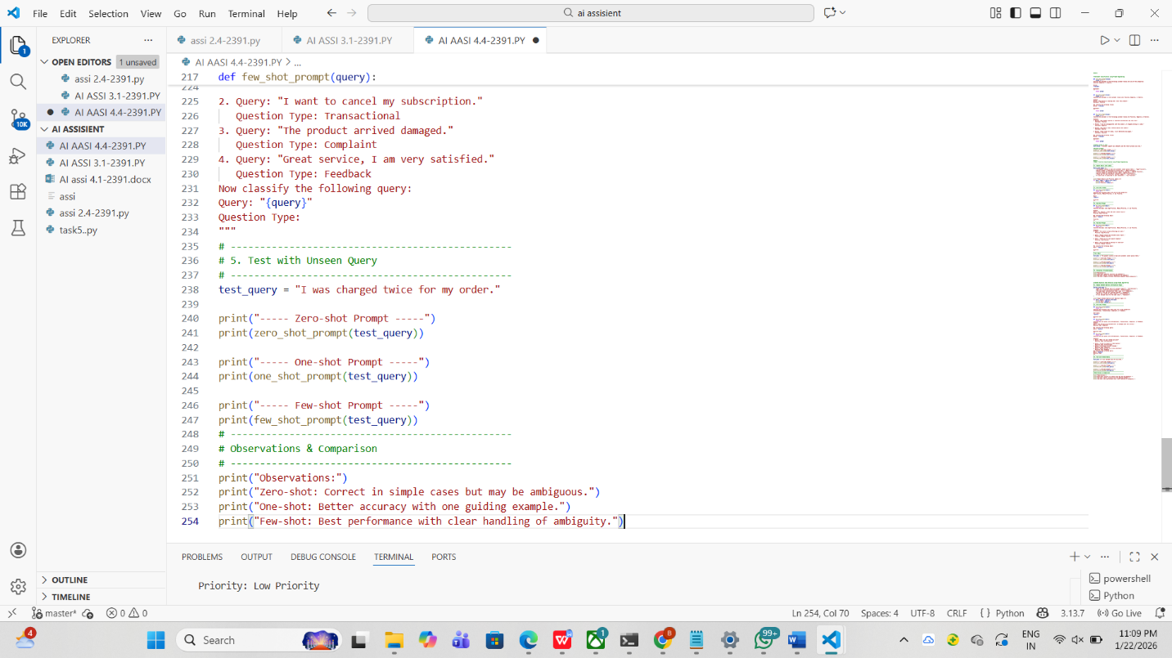

**OUTPUT:**

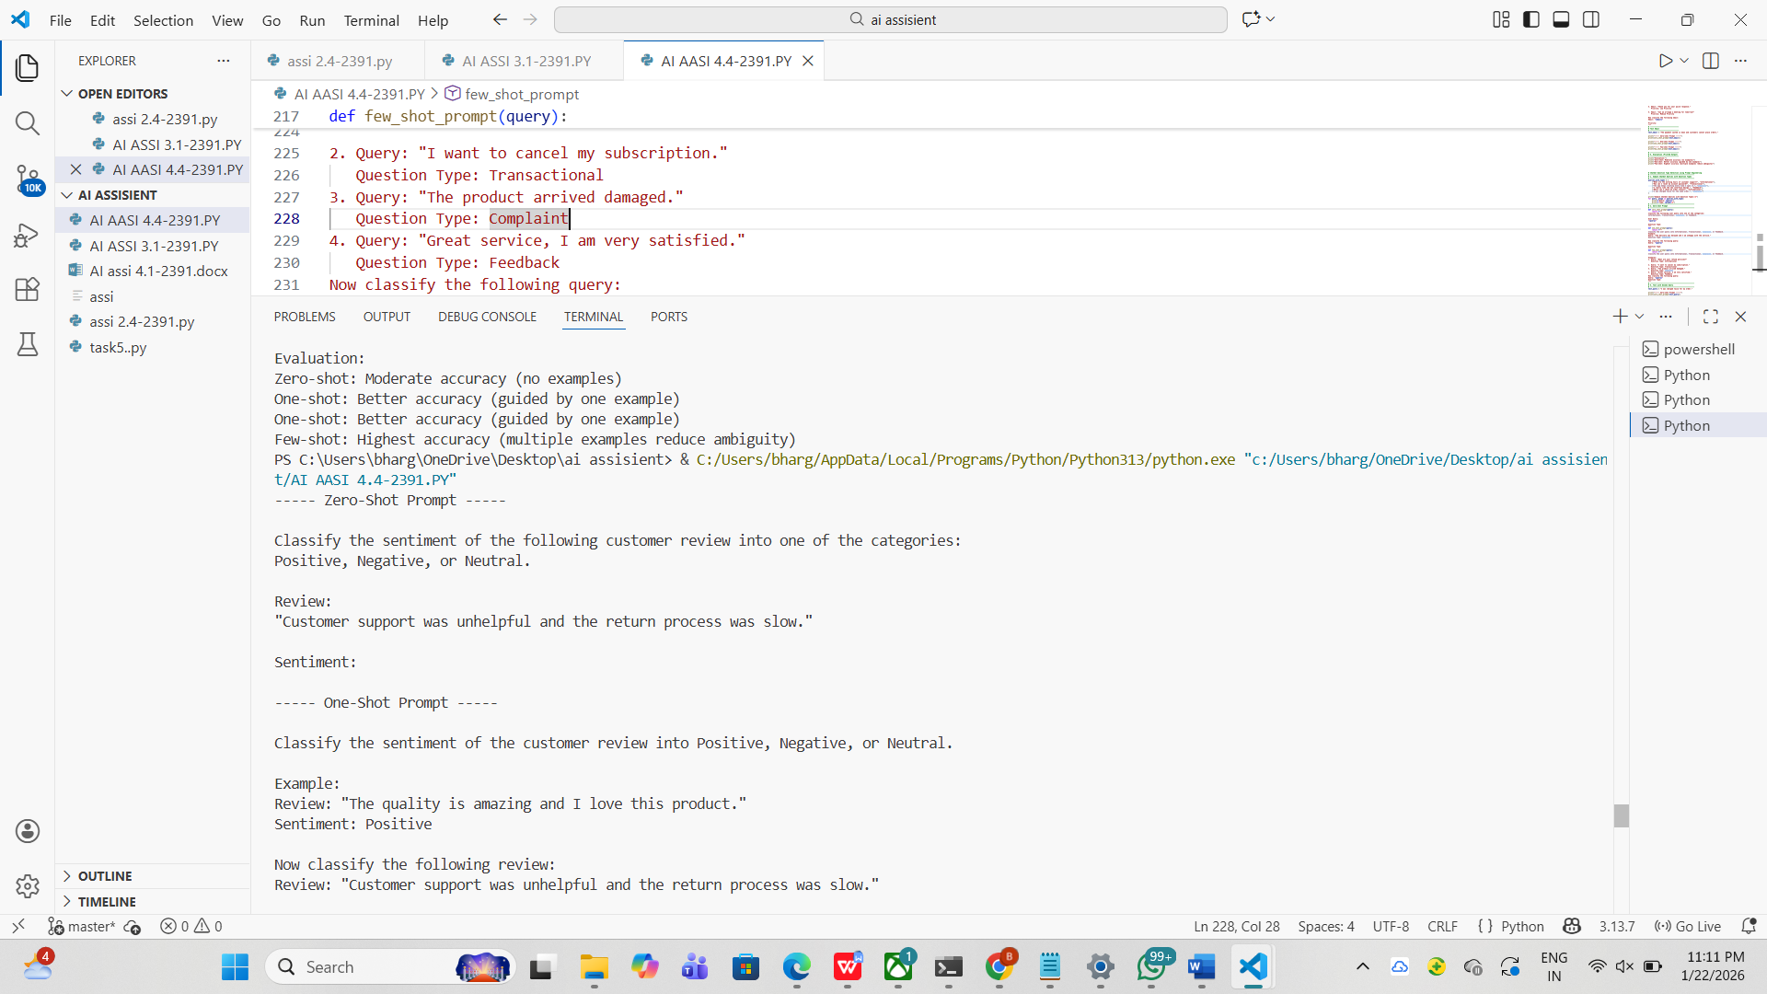

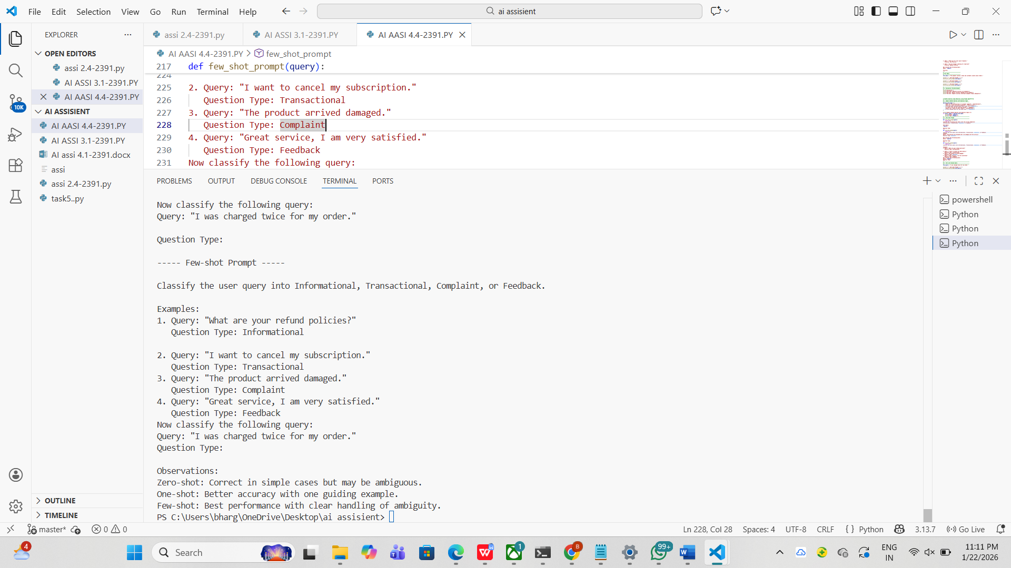

**5. Emotion Detection in Text**

**Scenario:A mental-health chatbot needs to detect emotions: Happy, Sad, Angry,**

**Anxious, Neutral.**

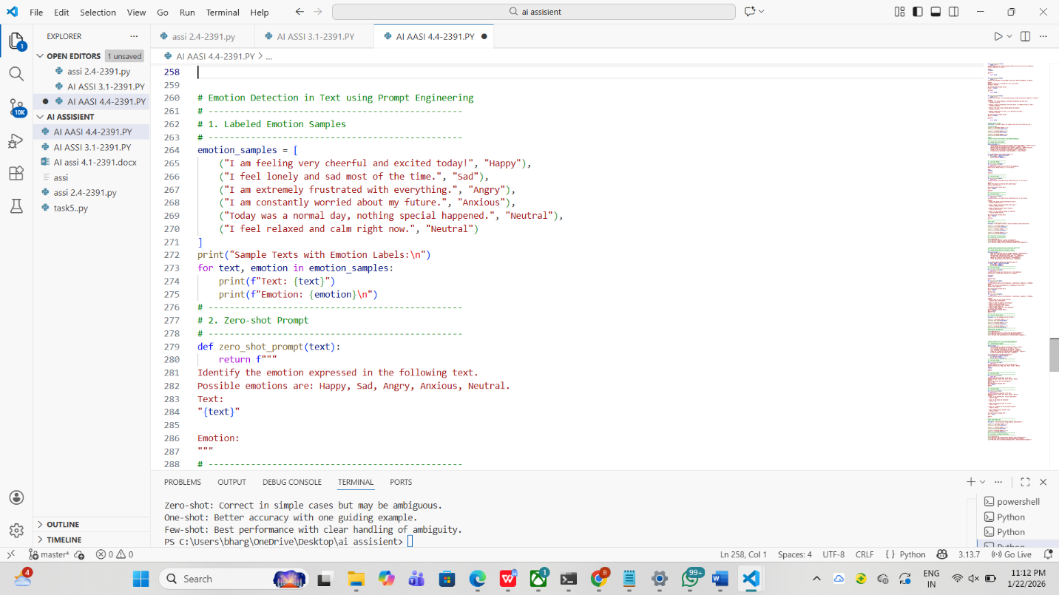

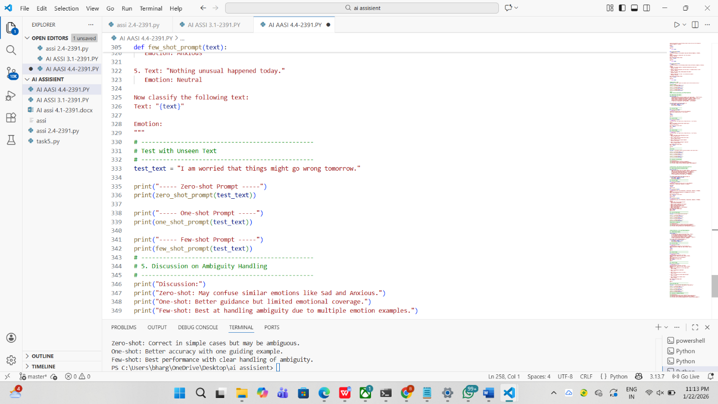

OUTPUT:

